
An open letter to John Rustad and the BC Conservative Party
October 4, 2024
Greetings Honourable Mr. Rustad and the BC Conservative Party:
I just read the BC conservative's child care policy announcement.
I am a low-income single mother and have researched child care data and policy for over 20 years. I include screen shots of current government data below.
Our organization, Kids First Parent Association of Canada, opposes all forms of discrimination against children, parents, and women based on the form of child care used.
We are preparing a Charter Challenge against the BC government on the issue of discrimination in child care policy.
We define 'child care' inclusively: child care is the care of a child including parental child care.
All children need child care 24/7/365.
We hope you agree.
However, discriminatory BC child care laws define child care to exclude parental child care altogether. Policies fund government- and ‘non-profit’-run daycare centres far more than any other type of child care – by parents, grandparents, friends, nannies, private centres, or home daycares.
Thus parental child care gets $0 funding while daycare centres spaces - especially government-run and 'non-profit'-run centres - are funded the most.
Policy ensure that parents do not control child care funds. Why are parents not trusted?
‘$10/day’ daycare centre funding is not tied to income. High income families use daycare centres more than low-income families.
Will you support discrimination in child care funding?
WE URGE YOU TO:
*DEFINE CHILD CARE INCLUSIVELY TO INCLUDE PARENTAL CHILD CARE.
*FUND ALL CHILD CARE BY FUNDING PARENTS DIRECTLY BASED ON THE NUMBER & AGE OF CHILDREN, AND FAMILY INCOME, NOT BASED ON CHILD CARE TYPE.
I note with some hope that you indicate that parental child care is child care. Your announcement says:
Provide financial relief for all lower and middle income families. The Affordable Childcare Benefit and BC Family Benefit will be reviewed and increased so families have what they need to look after their kids - whether they prefer childcare outside the house, at home with parents, or with support from family members.
However, it is clear that you are getting your talking points and data interpretation from the daycare lobby or others who do not present child care data correctly (the data is difficult to find to understand).
The loud, organized voices of proponents of discrimination against parents who want more funding for daycare get far more attention than warranted. Some receive public funds to lobby government.
They do not represent the vast majority of BC parents, children, and voters. They represent their own interests. Billions of dollars are involved after all. Parents are not organized but do vote.
So-called ‘waitlists' have no validity as a measurement of demand for non-parental child care. ‘Waitlists’ create unwarranted distress for parents and daycare providers.
High vacancy rates - empty spaces - and low enrollment in licensed child care are long-standing, little reported facts.
Here is the latest data from BC gov on new, funded spaces that are NOT OPERATIONAL - that is vacant: approximately 20,000 of 40,000 ‘spaces’. This is a waste of funds meant to support children.
B.C. Education System Performance - Child Care (gov.bc.ca)
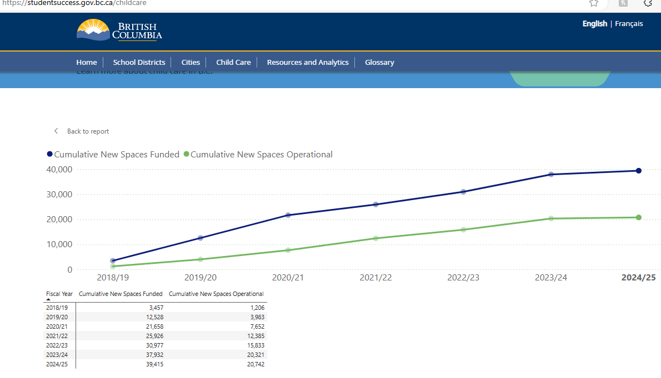
Statistics Canada's 2023 Canadian Survey on Early Learning and Child Care (CSELCC) represents 83% of the population age 0-5.
Surveys and statistical programs - Canadian Survey on Early Learning and Child Care (CSELCC) (statcan.gc.ca)
The CSELCC data for 2023 shows that 54.5% of BC children 0-5 in the 83% sample were in ANY form of non-parental child care for ANY amount of time.
Thus 45.5% if BC children age 0-5 were in parental child care ONLY. 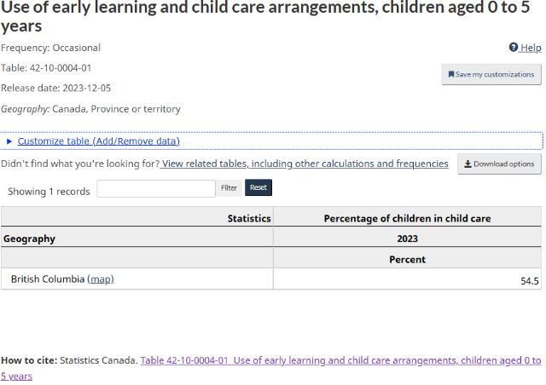
Only 34.5% of this 54.5% were in preschool or daycare centres.
Do the math: this means only 18.8% age 0-5 spent any time in preschool or daycare centres.
The vast majority - 81.2% - were not in preschool or daycare centres at all.
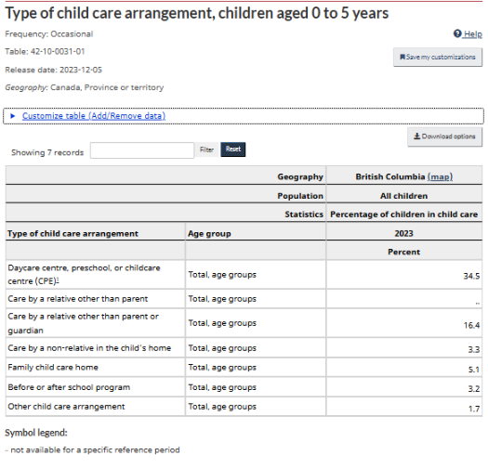
Thus, the vast majority of children and families get none or little of the billions spent on child care.
This low enrollment in daycare centres and licensed child care in general is despite the tremendous social, political, and financial pressure to coerce parents to use non-parental child care.
Meanwhile parental child care receives no recognition, appreciation or funding.
The UBC study found only 17 low-income single mothers using $10/day daycare because most low-income single mothers do not use daycare centres.
I trust you will take a closer look at child care data.
As it is, your policy may continue the long, sad history of discrimination against parental child care and parental control of child care decision making.
The daycare lobby has various factions. There are those who want more money for private operators and those who want the money for non-profit and government-run centres.
But neither of these factions represents the obvious need for equity, diversity, inclusion for all children. Remember: all children need child care 24/7/365.
Common sense and respect for parents is lost in the noise and data disinformation.
I am available to assist in reviewing data and policy.
Again, we urge you to
*DEFINE CHILD CARE INCLUSIVELY TO INCLUDE PARENTAL CHILD CARE.
*FUND ALL CHILD CARE BY FUNDING PARENTS DIRECTLY BASED ON THE NUMBER & AGE OF CHILDREN, AND FAMILY INCOME, NOT BASED ON CHILD CARE TYPE.
All the best,
Helen Ward (in Burnaby, BC cell 604-652-8297)
President
Kids First Parent Association of Canada
www.kidsfirstcanada.org
info@kidsfirstcanada.org
604-291-0088

