FUND THE CHILD - BC ELECTION CHILD CARE DATA UPDATE
OCTOBER 2026
Helen Ward, President
Kids First Parent Association of Canada www.KidsFirstCanada.org
info@kidsfirstcanada.org 604-291-0088, mobile: 604-652-8297
Apologies for any errors and typos. Contact author with corrections.
CONTENTS
SUMMARY
POLICY RECOMMENDATIONS
DATA
1 – PARENTAL CARE MOST USED TYPE: 47% OF KIDS 0-5 USE NO NON-PARENTAL CARE
2 – LOW ENROLMENT: ONLY 25% OF BC KIDS 0-12 IN ANY REGULATED CHILD CARE
3 – EXPENDITURE OVER $1.6 BILLION
4 - FEDERAL FUNDING
5 – $10/DAY FED FUNDS BASED ON PER CHILD AMOUNT FOR ALL KIDS: MOST GET $0
6 - $10/DAY FUNDING BASED ON 80% ENROLMENT = 20% VACANCY RATE
7 - LOW INCOME FAMILIES USE LESS LICENSED DAYCARE & RECEIVE LESS FUNDING
8 – $15,000/YEAR PER CHILD AVAILABLE IN ‘FEE SUBSIDIES’ ALONE
9 – OVER $350K/YR: SOME “NON-PROFIT” DAYCARE STAFF HAVE VERY HIGH INCOMES
10 - $11,100 = AVERAGE EXPENDITURE PER REGULATED SPACE 2024
11 - $10,580 = AVERAGE EXPENDITURE PER ENROLLED CHILD AGE 0-12 2024
12 - $2,630 = AVERAGE EXPENDITURE PER CHILD AGE 0-12 2024, MOST GET $0
13 - FUNDING BUREAUCRACY FOR MANY PROGRAMS
14 – OVER 11,500 NEW VACANT DAYCARE SPACES
15 – 30% VACANCY RATES IN LICENSED CHILD CARE PRIOR TO $10/DAY EXPANSION
16 - LASTING HARM TO CHILDREN & PARENTS FROM QUEBEC DAYCARE SYSTEM: TOP CANADIAN ECONOMISTS
17 - DAYCARE DOES NOT ‘PAY FOR ITSELF’
SUMMARY
Evidence is provided with links to sources and screen shots. The evidence in this update is from Statistics Canada, the BC government, and the Child Care Resource and Research Unit (CRRU) – a leading daycare advocacy organization federally funded by Employment and Social Development Canada to collect and publish national child care data, peer-reviewed research, and the Supreme Court of Canada.

The evidence shows that:
- discrimination against parents and children and inefficiency are the norm in child care
- over 47% age 0-5 use no non-parental child care - exclusive parental care is the most used form of child care
- most - 75% - of BC children age 0-12 do not use funded forms of child care and receive no child care funding
- BC child care expenditures are over $1.6 billion/year
- 28+ different funded programs mean more bureaucracy and less funding for actual care
- BC has long standing high vacancy rates in licensed child care
- some ‘non-profit’ child care personnel have very high incomes
- high income families use licensed daycare more and receive more child care funding than low income families
POLICY RECOMMENDATIONS
- Build policy for families based on principles not lobbyists’ ideologies and claims:
peer-reviewed and reliable evidence
‘do no harm’ to child well-being
respect parent-child rights & attachment
do not discriminate against parents & children
no financial or social coercion of parents - especially of mothers - by government
fairness & human rights
inclusivity
empower parents to raise children without financial coercion in child care & education
- Publicly thank parents for their socially essential work raising children (we thank teachers and first responders and everyone but parents).
- Publicly confirm parents’ rights and responsibility for making decisions for their children according to the Supreme Court of Canada and numerous international human rights agreements. That court ruled that parental rights exist “because parents are more likely to appreciate the best interests of their children and because the state is ill-equipped to make such decisions itself.” https://scc-csc.lexum.com/scc-csc/scc-csc/en/item/1220/index.do
- End child care discrimination: Fund the Child; Funds Follow the Child: child care funds to go to parents based on the age and number of children, and income.
- At a minimum, commit to reviewing child care policy for compliance with Charter and Human Rights values, fairness, efficiency, child outcomes, and effectiveness.
- Create an advisory body on government policies affecting the parent-child relationship and rights. Invite Neufeld Institute, Kids First Parent Association of Canada, UBC economist Dr. Kevin Milligan; Drs Deborah Macnamara, Jay Belsky, James Heckman, etc.
DATA
1 – PARENTAL CARE MOST USED TYPE: 47% OF KIDS 0-5 USE NO NON-PARENTAL CARE
47.2% of BC children age 0-5 did not use any non-parental child care in previous 3 weeks. 52.8 % use some type and some amount of non-parental child care
SOURCE – Statistics Canada – Survey on Early Learning and Child Care Arrangements 2025
https://www150.statcan.gc.ca/t1/tbl1/en/cv.action?pid=4210010301
SCREEN SHOT
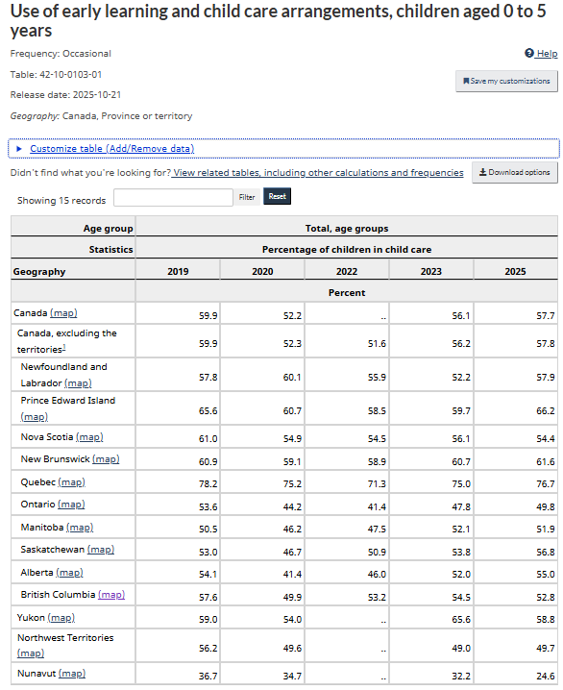
2 – LOW ENROLMENT: ONLY 25% OF BC KIDS 0-12 IN ANY REGULATED CHILD CARE
Enrolment does not mean attendance: enrolled children usually do not attend all the hours or days their space is funded for due to illness, schedule, vacations, other care arrangements. In BC ‘full time’ means over 4 hours/day.
AGE 0-5:
* According to Statistics Canada SELCCA 2025 31.8% - under one third - of BC children age 0-5 in 2025 were enrolled in preschool or daycare centres. The percentage is about the same as it was in 2019 before the ‘$10/day’ daycare federal funding in 2021.
SOURCE:
Statistics Canada – Survey of Early Learning and Child Care Arrangements 2025 (SELCCA) Statistics Canada. Table 42-10-0108-01 Type of child care arrangement, children aged 0 to 5 years DOI: https://doi.org/10.25318/4210010801-eng
SCREEN SHOT
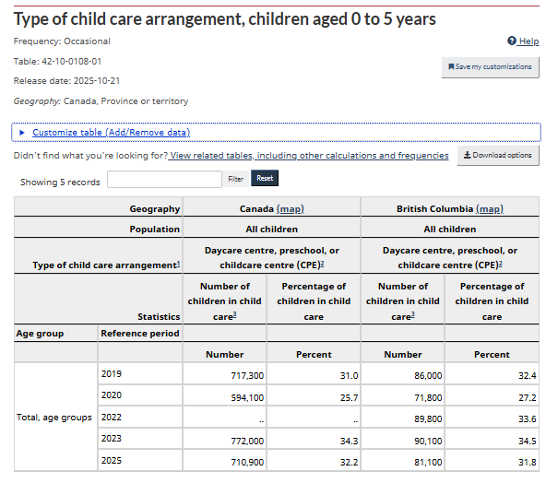
* According to the ECEC in Canada 2024-2025, in 2024 under one third – 29% - of BC children 0-5 were enrolled in full time daycare centres in 2024: 75,331 (74,994 in daycare centre + 337 in multiage care) out of 0-5 population of 258,900.
* AGE 0-12:
According to the ECEC in Canada 2024-2025, in 2024 only about one quarter – 24.9% - of BC children 0-12 were enrolled in any type of regulated child care (centre, family, preschool, out-of-school, etc): 155,537 of 0-12 population of 625,500.
SOURCE:
number of children
BC 2024 population: 0-5: 258,900 (119,300 age 0-2 + 139,600 age 3-5); 0-12: 625,500
CRRU – ECEC in Canada 2024 p. 306 https://childcarecanada.org/sites/default/files/ECEC-2024-2025-British-Columbia.pdf
SCREEN SHOT
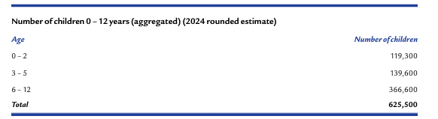
SOURCE:
enrolment in regulated child care
ECEC-2024-2025-British-Columbia.pdf p 327
SCREEN SHOT
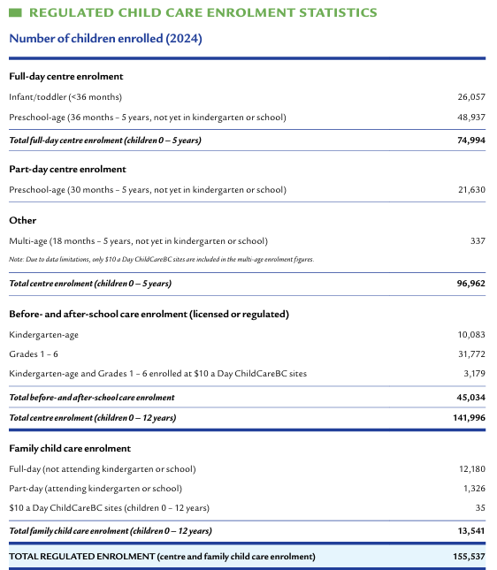
3 – EXPENDITURE OVER $1.6 BILLION
In 2023-2024 BC spent $1,645,526,214 ($1,577,678,802 ‘for regulated child care’ + $67,847,412 in ‘other ELCC funding’) in on child care. Excluded: municipal child care expenditures, ‘in kind’ funding (eg free rent), and daycare funding by universities.
SOURCE: p.335 https://childcarecanada.org/sites/default/files/ECEC-2024-2025-British-Columbia.pdf
SCREEN SHOT
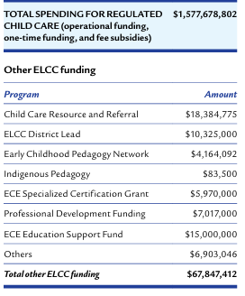
4 - FEDERAL FUNDING
BC received a total of $747,986,049 in 2023-2024 from 3 federal child care funding streams. This is 45.5% of the total expenditure of $1,645,526,214.
SOURCE: p.335 https://childcarecanada.org/sites/default/files/ECEC-2024-2025-British-Columbia.pdf
SCREEN SHOT
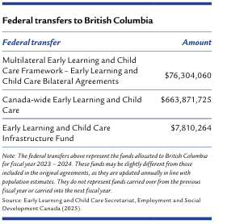
‘$10/day’: CANADA-WIDE EARLY LEARNING AND CHILD CARE AGREEMENT (CWELCC)
CWELCC is by far the largest federal funding stream. This funding increases yearly with nearly $911 million for BC estimated for 2025-26, up 39% from $654,355,932 estimated for 2023-24.
SOURCE:
https://www.canada.ca/en/early-learning-child-care-agreement/agreements-provinces-territories/british-columbia-canada-wide-2021.html#h2.6
SCREEN SHOT
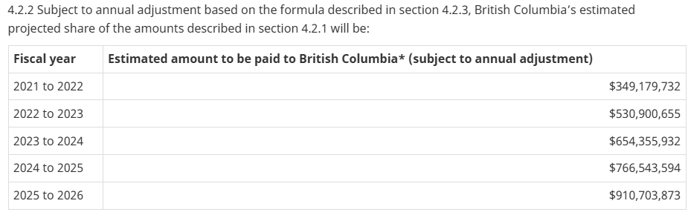
5 – $10/DAY FED FUNDS BASED ON PER CHILD AMOUNT FOR ALL KIDS: MOST GET $0
Federal Canada-Wide Early Learning and Child Care Agreement (CWELCC) funds for $10/day daycare are calculated based on an unspecified per child age 0-12 amount.
However, most children – about 75% - receive no funding.
SOURCE:
Canada-British Columbia Canada-Wide Early Learning and Child Care Agreement – 2021 to 2026 - Canada.ca
SCREEN SHOT
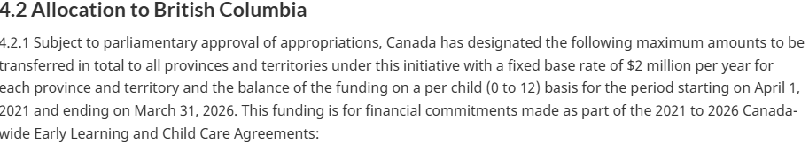
6 - $10/DAY FUNDING BASED ON 80% ENROLMENT = 20% VACANCY RATE
“$10 a Day sites must meet specified conditions to receive individualized monthly payments based on an expectation of 80% enrolment.”
SOURCE:
p. 328 https://childcarecanada.org/sites/default/files/ECEC-2024-2025-British-Columbia.pdf
7 - LOW INCOME FAMILIES USE LESS LICENSED DAYCARE & RECEIVE LESS FUNDING
* Canada-wide in 2023, 60% of families ‘not in low income’ used any type of non-parental child care vs only 41% of low income families according to Statistics Canada.
Under one third – 32% - of low income families Canada-wide used any licensed child care (41% in low income using any non-parental child care X 77% of these using licensed child care). 46.2% of families ‘not in low income’ (60% not in low income using any non-parental care x 78% of these using licensed care). That’s 55% more families ‘not in low income’ receiving licensed child care funding.
Many families are low income because they reduce time doing waged work in order to spend more time providing parental child care.
SOURCE:
https://www150.statcan.gc.ca/n1/pub/11-627-m/11-627-m2025042-eng.htm
SCREEN SHOTS
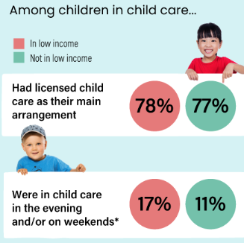

8 – $15,000/YEAR PER CHILD AVAILABLE IN ‘FEE SUBSIDIES’ ALONE
* Income tested ‘fee subsidies’ paid directly to daycares are worth up to $1,250/month = $15,000/year per child under BC’s Affordable Child Care Benefit. Full subsidies are available for incomes up to $45,000/year for a 1 or 2 parent family. Partial subsidies are available for incomes of $111,000 or more per year. The goal is to lower parents’ actual fees to $10/day or less.
SOURCE:
* https://www2.gov.bc.ca/gov/content/family-social-supports/caring-for-young-children/childcarebc-programs/child-care-benefit/information-for-families/eligibility-estimate-funding
* accb_client_journey_tri-fold.pdf
* $10/day daycare centres: no income or need testing - eg SFU, UBC $10/day used by high-income staff. Centres’ costs are paid based on their individual submitted budgets.
SOURCE:
* $10-a-Day ChildCareBC ($10-a-Day) — BC Childcare Subsidy Guide | Child Care Registry™
* Operating Funding Model - Province of British Columbia

9 - OVER $350K/YR: SOME “NON-PROFIT” DAYCARE STAFF HAVE VERY HIGH INCOMES
*YMCA: "the largest provider of licensed child care" in BC
over $350,000 – top BC YMCA staffer 2025
$160,000 or more - 9 others staffers
BC YMCA received nearly $61 million in gov't funding in 2025.
SOURCES:
*Child Care Programs | YMCA BC
* BC YMCA tax return T3010 Registered Charity Information Return
*UBC
fiscal year ending March 2025:
- $179,921 + $1,797 in expenses - Child Care Director Karen Vaughan was paid
- $116,837 - Associate Directors Deborah Thompson
- Other administrative staff: Dianne Tannahill $117,254, E. Point $90,828, E. Bowman $97,860, M. Walters $97,861, $N. Farrell $89,838, S Damen $93,402, M. Booth $88,027
- $200,134 + $13,836 expenses - Paul Kershaw – head of Gen Squeeze UBC-funded daycare lobby group
SOURCES:
UBC Child Care https://childcare.ubc.ca/about-us/who-we-are/
UBC SOFI 2025 https://vpfo-finance-2024.sites.olt.ubc.ca/files/2025/11/FY25-UBC-Statement-of-Financial-Information.pdf?_gl=1*10llstw*_ga*MTExNDg4NjY5My4xNzkxMjY1NjAy*_ga_3B1R282RNR*czE3OTEyNjU2NTkkbzEkZzAkdDE3OTEyNjU2NTkkajYwJGwwJGgw
*SFU
2025
$138,117 – Child Care Executive Director Rachel Day
SOURCES:
SFU Child Care https://www.sfu.ca/childcare/about-us/team.html#adminstaff
SFU SOFI https://www.sfu.ca/content/dam/sfu/finance/publications-news/publications/SOFI/2025-SOFI-report.pdf
10 - AVERAGE EXPENDITURE PER REGULATED SPACE 2024
$11,103 was spent per space: $1,645,526,214 was spent to provide 148,201 regulated spaces for ages 0-12
SOURCE:
Number of spaces
p. 324 https://childcarecanada.org/sites/default/files/ECEC-2024-2025-British-Columbia.pdf
SCREEN SHOT
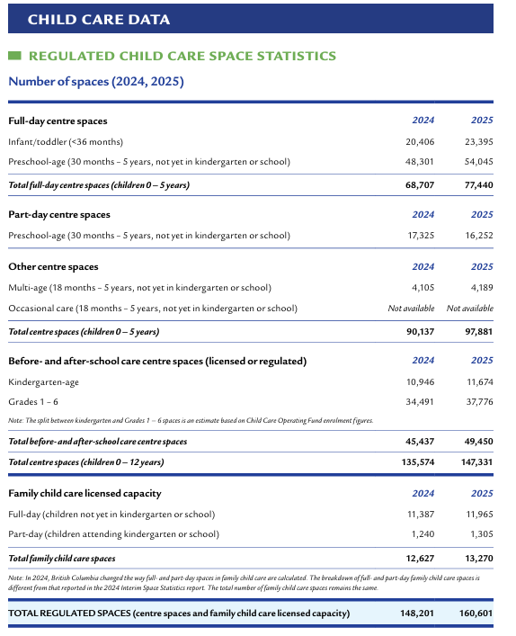
11 - $10,580 = AVERAGE EXPENDITURE PER ENROLLED CHILD 0-12 2024
$10,580 on average was spent per enrolled child: $1,645,526,214 was spent to provide regulated child care to 155,537 age 0-12
SOURCE:
Number of enrolled children 0-12 p. 327 ECEC-2024-2025-British-Columbia.pdf
12 - $2,630 = AVERAGE EXPENDITURE PER CHILD AGE 0-12 2024; MOST GET $0
Most - about 75% - children received no child care funding. $2,630 was spent on average per child 0-12. This is about $220/month: $1,645,526,214 was spent to provide regulated child care to the population of 625,500 age 0-12.
13 - FUNDING BUREAUCRACY FOR MANY PROGRAMS
About 28 programs in BC are funded with child care funds according to ECEC in Canada 20224-2025. There are 22 programs in the lists below (screen shot).
The total may be 28 including 6 other funded BC programs listed in ECEC in Canada 2025:
Seamless Day Kindergarten
Just B4
StrongStart BC
Aboriginal Head Start on Reserve (AHSOR)
Aboriginal Head Start in Urban and Northern Communities (AHSUNC)
Funding to the British Columbia Aboriginal Child Care Society (BCACCS), the Métis Nation of British Columbia, and the BC Association of Aboriginal Friendship Centres to undertake engagement, planning, professional development training, and culturally focused resources.
Not mentioned:
Funding for COVID-related supplies
Funding to make up for COVID-related lower enrolment
SOURCE:
lists of funded programs
pp. 334-335 ECEC-2024-2025-British-Columbia.pdf
SCREEN SHOT
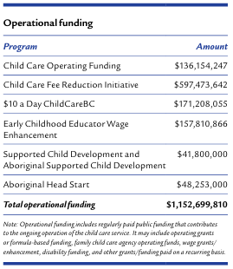
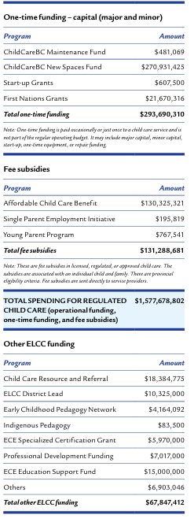
14 – OVER 11,500 NEW, FUNDED DAYCARE SPACES ARE VACANT
According to BC government data, there are currently (Oct 2026) 11,583 new, funded child care spaces that are vacant, not ‘operational’: 31,380 spaces are ‘operational’ out of a total of 43,025 new, funded spaces.
SOURCE:
https://studentsuccess.gov.bc.ca/childcare
SCREEN SHOT
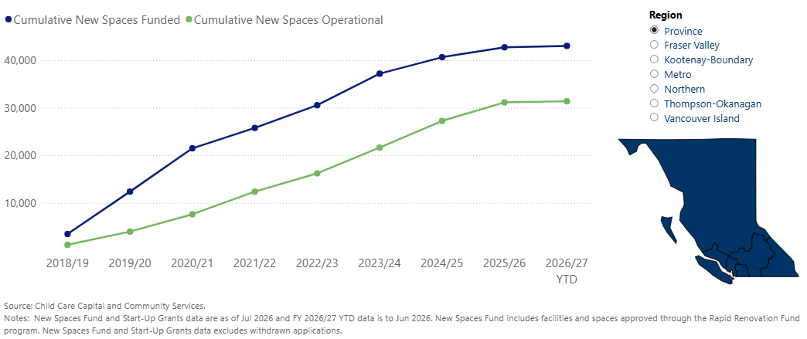
SOURCE: https://view.officeapps.live.com/op/view.aspx?src=https%3A%2F%2Fstudentsuccess.gov.bc.ca%2Fcc%2Fgovernment-funded-space-creation.xlsx&wdOrigin=BROWSELINK
SCREEN SHOT
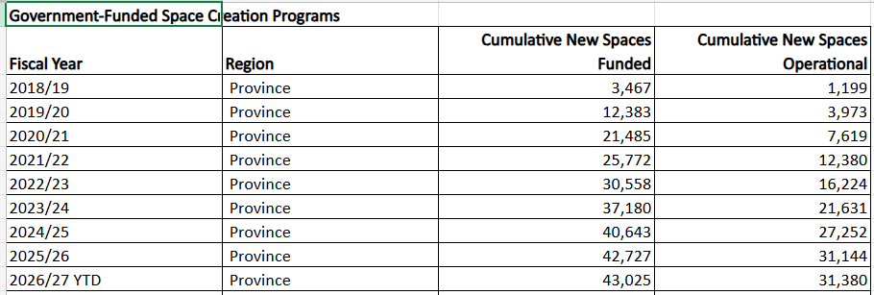
15 – 30% VACANCY RATES IN LICENSED CHILD CARE PRIOR TO $10/DAY EXPANSION
Despite decades of claims of shortages of daycare spaces and more recently of ‘child care deserts’, vacancy rates of 30% or more in licensed child care were the norm prior to $10/day. The vacancy rate was 29% in 2017; vacancy rates ranged from 8.9% to 69.7%.
According to annual Ministry of Child and Family Development ‘Performance Management Reports’, the problem of ‘spare capacity in licensed child care’ - high vacancy rates, or low ‘utilization rates’ - was the norm. High vacancy rates were considered a ‘performance indicator’ that needed to be improved long before the $10/day daycare launch.
SOURCE:
p 15 https://www2.gov.bc.ca/assets/gov/family-and-social-supports/services-supports-for-parents-with-young-children/reporting-monitoring/00-public-ministry-reports/volume_9_mar_2017.pdf
SCREEN SHOT
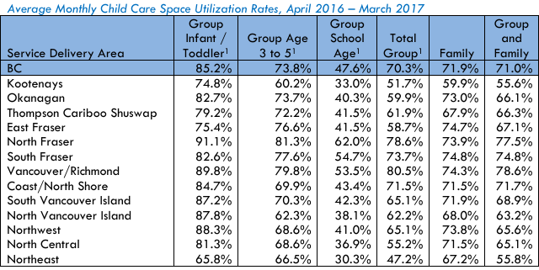
SOURCE:
p.14 https://www2.gov.bc.ca/assets/gov/family-and-social-supports/services-supports-for-parents-with-young-children/reporting-monitoring/00-public-ministry-reports/volume_9_mar_2017.pdf
SCREEN SHOT
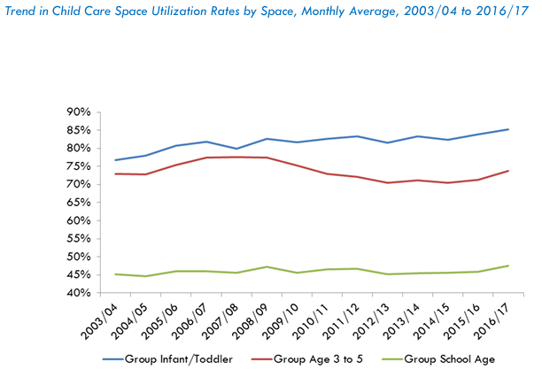SOURCE:
P.15 https://www2.gov.bc.ca/assets/gov/family-and-social-supports/services-supports-for-parents-with-young-children/reporting-monitoring/00-public-ministry-reports/volume_8_draftv7.pdf
SCREEN SHOT

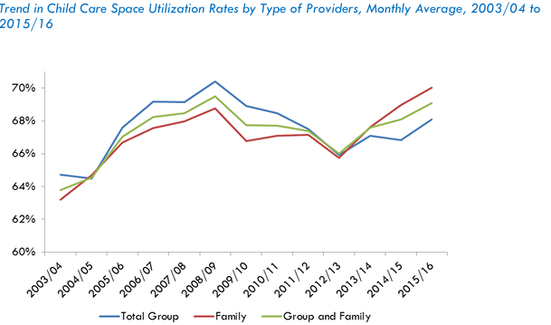
SOURCE:
p.17 https://www2.gov.bc.ca/assets/gov/family-and-social-supports/services-supports-for-parents-with-young-children/reporting-monitoring/00-public-ministry-reports/volume_8_draftv7.pdf
SCREEN SHOT
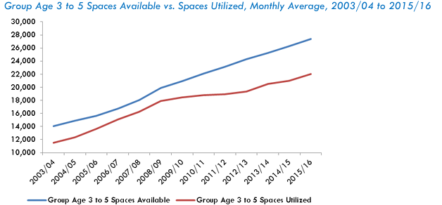

16 - LASTING HARM TO CHILDREN & PARENTS FROM QUEBEC DAYCARE SYSTEM: TOP CANADIAN ECONOMISTS
* Top Canadian economists including UBC’s Kevin Milligan found that under the Quebec daycare system “…children are worse off by measures ranging from aggression to motor and social skills to illness…. the new child care program led to more hostile, less consistent parenting, worse parental health, and lower‐quality parental relationships….The consistency of the results suggests that more access to childcare is bad for these children.”
* Their 20 year follow-up study found “…the negative effects on noncognitive outcomes persisted to school ages, and also that cohorts with increased child care access had worse health, lower life satisfaction, and higher crime rates later in life.”
SOURCE:
* “The Long-Run Impacts of a Universal Child Care Program”, American Economic Journal: Economic Policy, Vol. 11, No. 3 (2019), pp. 1-26 The Long-Run Impacts of a Universal Child Care Program - American Economic Association
* “Universal Childcare, Maternal Labor Supply and Family Well-Being” Journal of Political Economy Aug 2008 https://doi.org/10.1086/591908

17 - DAYCARE DOES NOT ‘PAY FOR ITSELF’
The fallacy that funding daycare generates $2-17+ for every $1 spent is based on “jaw dropping…gross misrepresentation” (Dr Kevin Milligan) of the work of Nobel Laureate economist Dr James Heckman by daycare proponents. Heckman says of this claim, “I was horrified because I never said that.” Heckman found that a few *intervention* programs – not daycare - that “empowered mothers” of very disadvantaged children produced a long- term cost-benefit return of 13%/yr.
Heckman says: “…we can empower parents. But the whole activity has to be to engage the family. So, I think it’s the family, the family, the family. And I don’t know if public policy has gotten there yet.”
SOURCE:
* Talking to economist Kevin Milligan | Archive of IMFC
* 210225-James-Heckman-on-the-role-of-families-in-human-flourishing.pdf

